Guided Capstone Project Report

Big Mountain Resort has added an additional chair lift that increased operating cost of 1.54 M this season. Current strategy is to charge a premium above average price. Currently, they base their pricing on market average. There is suspicion that they are not capitalizing on offered facilities. The objective of this report is to determine what facilities to capitalize on to justify cutting costs or increasing revenue price. As such, the aim of this report was to build a predictive model for ticket price based on a number of facilities. At first, it is important to look at where Big Mountain Resort (BMR) falls comparingly against all state resorts and Montana individually. Figure 1, shows that BMR’s average weekend ticket price falls at $81 USD where it puts it at a higher distribution against other average prices. Figure 1 also details that BMR is at the top bracket for pricing in Montana. Collectively, Montana’s average prices for both AdultWeekday and AdultWeekend sits at $51.91 for both ticket prices.

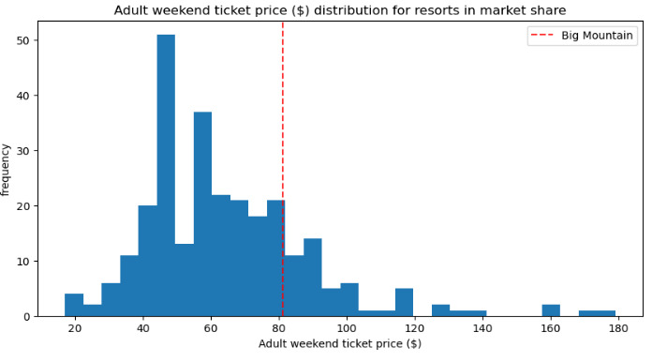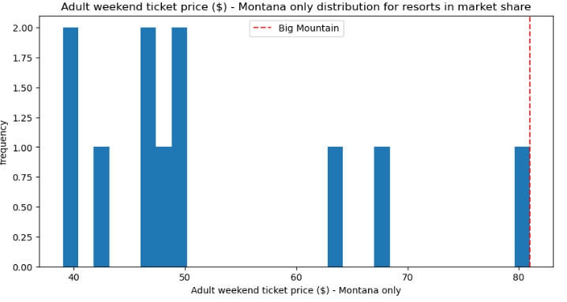

Figure 1: All state price distribution and Montana price distribution

A linear model was performed and their coefficients determined that vertical drop is the biggest positive feature followed by Snow Making_ac. It also shows that SkiableTerrain_ac is negatively associated with ticket price which implies that people will pay less for larger resorts. A random forest regressor was also performed and their importance values determined that fasQuads, Runs, Snow Making_ac, and vertical_drop lead in that order for top 4 features (Figure 2). Performance for both linear regression model and random forest regressor model were then compared by cross validation for their mean absolute error with values of $11.79 and $9.48 respectively. Thus, random forest regressor was chosen as the best optimal model to gain insights for its lower mean absolute error pertaining price and demonstration of less variability.

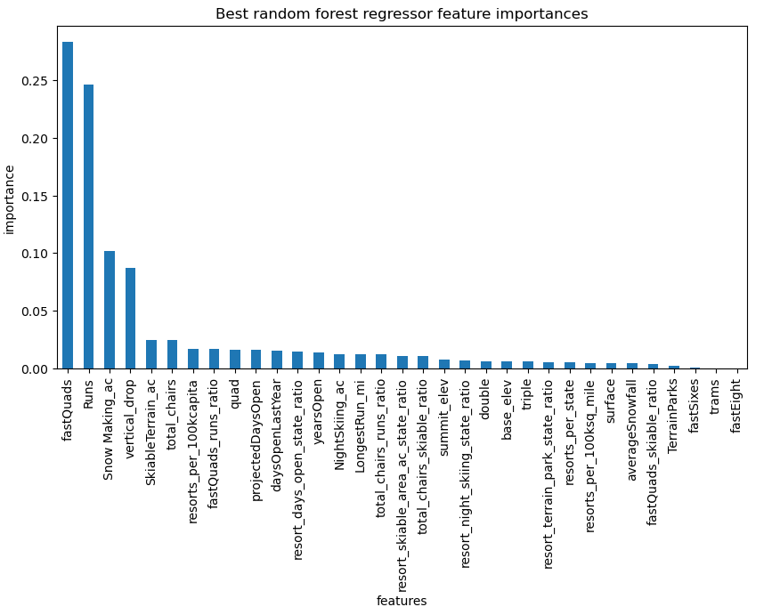

Figure 2: Best Random Forest regressor feature importances

We then take our best optimal model for ski resort ticket price to gain insights as to what facilities could justify BMR’s price increase to account for operations cost, while also exploring other changes in resort parameters. It is important to acknowledge that these findings are under the assumption that other resorts also base their prices on how much people value certain facilities. As such the next step is to refit the model to predict BMR’s ticket price based on all the data from the other resorts. It was then determined the predicted model price to be $102.18 compared to the actual price of $81, even with an expected mean absolute error of $10.24. This suggests that there is room for increase in price. Furthermore, the features that came up important in the modeling are: vertical_drop, Snow Making_ac, total_chairs, fastQuads, Runs, LongestRun_mi, trams, and SkiableTerrain_ac. These features for BMR are then compared to the market share, where for most, other than trams, these features for BMR are in a higher bracket. Quickly summarizing, the values for these are 2353 ft, 600 acres, 14 chairs, 3 fastQuads, 105 runs, 3.3 miles of longest run, 0 trams, and 3000 acres of skiable terrain respectively.

These then are taken in consideration while BMR is reviewing scenarios for either cutting cost or increasing revenue from ticket prices. It is important to note that ticket price is not determined by any set of parameters but also consider that people pay more or less for certain features in this current market.

These four possible scenarios are:

1. Permanently closing up to 10 of least used runs. This doesn't impact any other resort statistics.
2. Increase the vertical drop by adding a run 150 feet lower down but requiring the installation of an additional chair lift to bring skiers back up, without additional snow making coverage.
3. Same as number 2, but adding 2 acres of snow making cover.
4. Increase the longest run by 0.2 mile to boast 3.5 miles length, requiring an additional snow making coverage of 4 acres

Looking at Scenario 1, if we close 1 run, we will not see a difference in pricing/revenue. Closing 2 and 3 results in lower ticket pricing and revenue drops as a result. Closing 4 and 5 runs makes no difference, but if we close 6 or more runs, we see a steep drop in ticket pricing and revenue (Figure 3).

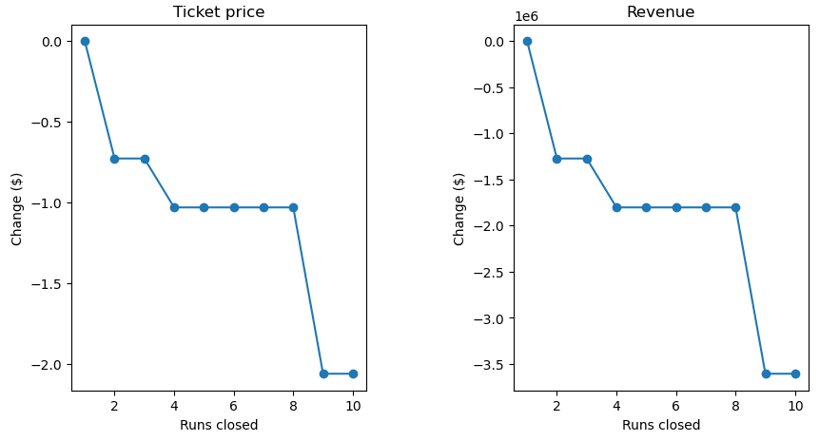

Figure 3: Ticket price versus number of runs closed

Scenario 2 parameters support a ticket price increase by $1.58 where a revenue increase of $2,757,576 could be seen. Scenario 3 adds an additional Snow Making component to Scenario 2, but it makes no difference and yields the same result as Scenario 2. You could say it would add to operating cost by adding Snow Making_ac. Scenario 4 calls to increase the longest run by 0.2 miles and add 4 acres of Snow Making but also made no difference whatsoever. Thus, comprehensively looking at all options, the best route for BMR to take is to proceed with Scenario 2 of increasing the price to $82.58 that would offset the operating cost of the additional chair added of $1.54 M.